The Plano office is located at 1200 Medical Avenue, Suite 103, Plano, Texas 75075. Visitor parking is available in front of the building. The number to the Plano office is 214-540-0660.

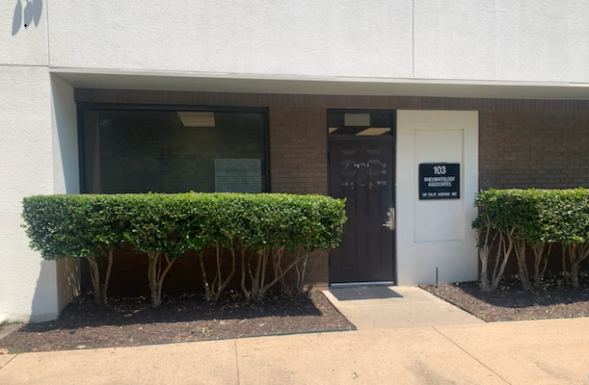

When heading east on 15th Street, we are on the right-hand side, opposite the street from the hospital, east of the Coit intersection.
Once you turn right onto Medical Avenue, you must continue until you reach the last building on the left (approximately ¼ miles). We are in a single-story building with 4 office spaces across the street from a 3-story apartment complex.

