The North Richland Hills office is located at 8221 Mid Cities Blvd, Suite 200, North Richland Hills, Texas 76182. Visitor parking is in front of the building. The number to the North Richland Hills office is 214-540-0700 Ext 1761.

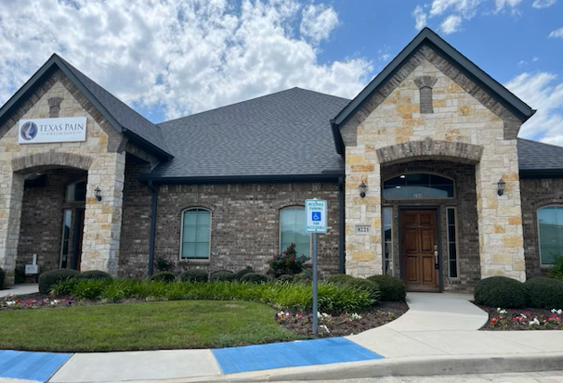

Directions to the North Richland Hills office:
COMING FROM IRVING
TAKE 183 (AIRPORT FREEWAY WEST) TOWARDS FORT WORTH; EXIT PRECINCT LINE ROAD AND TURN RIGHT; TURN LEFT ON MID CITIES BLVD.

COMING FROM GRAPEVINE:
TAKE 26 SOUTH TO CHEEK SPARGER ROAD AND TURN RIGHT; CONTINUE ON CHEEK SPARGER ROAD TO MID CITIES BLVD.

COMING FROM FORT WORTH:
TAKE 121 NORTH TO 820 NORTH; TURN LEFT ON FM 1938 (NORTH DAVIS BLVD), TURN RIGHT ON MID CITIES BLVD.

