The Grapevine office is located at 1643 Lancaster Drive, Suite 202, Grapevine, Texas 76051 on the 2nd floor. We are across the street from Baylor Scott and White Grapevine in the Professional Building, Clearview I.

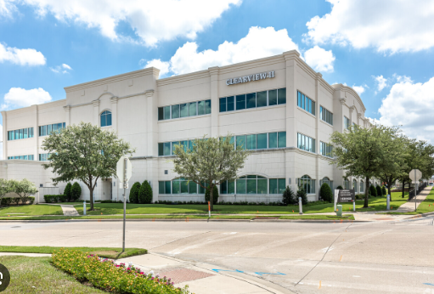

Coming from IRA E. Woods. Turn onto Lancaster Dr. to Clearview I Bldg. Pull into the parking garage. Go through the sliding door and take the elevator to the 2nd floor.

Coming in the back way off College, take Lancaster Dr. to Clearview I Bldg. Pull into the parking garage. Go through the sliding door and take the elevator to the second floor.

Parking is also available on the 2nd level of the parking garage. Go through the door, and our office is on the right.

